ORDINANCE NO. 2023-09-13-02

VILLAGE OF MAPLETON, ILLINOIS

AN ORDINANCE TO AMEND THE ZONING MAP
OF THE VILLAGE OF MAPLETON, ILLINOIS

WHEREAS, the Village of Mapleton has petitioned for rezoning the property shown on the attached Exhibit A and legally described on the attached Exhibit B to the I-2 Heavy Industrial District classification, and the Village’s Zoning Chairperson has held a public hearing on such rezoning.

NOW, THEREFORE, BE IT ORDAINED BY THE PRESIDENT AND VILLAGE BOARD OF THE VILLAGE OF MAPLETON, PEORIA COUNTY, ILLINOIS, AS FOLLOWS:

Section 1: The zoning map of the Village of Mapleton shall be amended so as to classify the subject property to the I-2 Heavy Industrial District classification.

Section 2: This Ordinance shall take effect and be in full force from and after its passage and publication as provided by law.

PASSED AND APPROVED THIS _______ DAY OF , 2023.

______ AYES
______ NAYS
______ ABSENT

VILLAGE OF MAPLETON, ILLINOIS

By: _______________________________
Liz Rench, President

Attest: ______________________________
Diana Merritt, Village Clerk

423-0358

EXHIBIT A

ANNEXATION PLAT
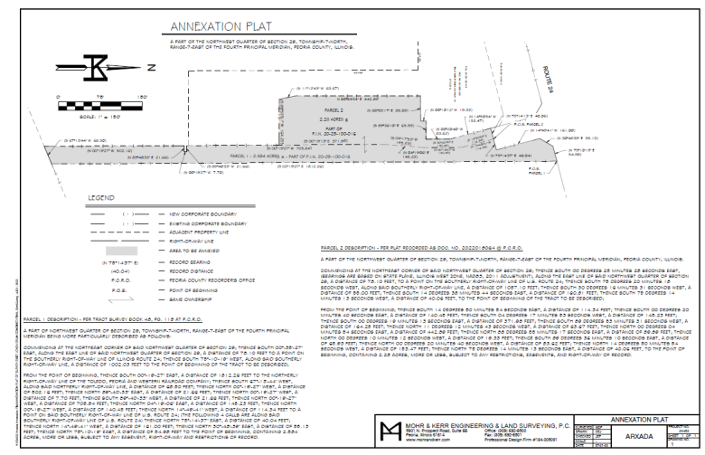

EXHIBIT B

ANNEXATION LEGAL DESCRIPTION FOR
TAX PARCEL 20-29-100-016

Parcel 1:

A PART OF THE NORTHWEST QUARTER OF SECTION 29, TOWNSHIP-7-NORTH, RANGE-7-EAST OF THE FOURTH PRINCIPAL MERIDIAN BEING MORE PARTICULARLY DESCRIBED AS FOLLOWS:

COMMENCING AT THE NORTHEAST CORNER OF SAID NORTHWEST QUARTER OF SECTION 29; THENCE SOUTH 00°-35'-27" EAST, ALONG THE EAST LINE OF SAID NORTHWEST QUARTER OF SECTION 29, A DISTANCE OF 78.10 FEET TO A POINT ON THE SOUTHERLY RIGHT-OF-WAY LINE OF ILLINOIS ROUTE 24; THENCE SOUTH 75°-10'-19" WEST, ALONG SAID SOUTHERLY RIGHT-OF-WAY LINE, A DISTANCE OF 1002.03 FEET TO THE POINT OF BEGINNING OF THE TRACT TO BE DESCRIBED;

FROM THE POINT OF BEGINNING, THENCE SOUTH 00°-19'-27" EAST, A DISTANCE OF 1812.26 FEET TO THE NORTHERLY RIGHT-OF-WAY LINE OF THE TOLEDO, PEORIA AND WESTERN RAILROAD COMPANY; THENCE SOUTH 67°-13'-44" WEST, ALONG SAID NORTHERLY RIGHT-OF-WAY LINE, A DISTANCE OF 68.50 FEET; THENCE NORTH 00°-19'-27" WEST, A DISTANCE OF 502.16 FEET; THENCE NORTH 89°-40'-33" EAST, A DISTANCE OF 21.66 FEET; THENCE NORTH 00°-19'-27" WEST, A DISTANCE OF 7.70 FEET; THENCE SOUTH 89°-40'-33" WEST, A DISTANCE OF 21.66 FEET; THENCE NORTH 00°-19'-27" WEST, A DISTANCE OF 705.84 FEET; THENCE NORTH 04°-19'-06" EAST, A DISTANCE OF 145.23 FEET; THENCE NORTH 00°-19'-27" WEST, A DISTANCE OF 140.45 FEET; THENCE NORTH 14°-49'-41" WEST, A DISTANCE OF 110.17 FEET TO A POINT ON SAID SOUTHERLY RIGHT-OF-WAY LINE OF U.S. ROUTE 24; (THE FOLLOWING 4 CALLS ARE ALONG SAID SOUTHERLY RIGHT-OF-WAY LINE OF U.S. ROUTE 24) THENCE NORTH 75°-14'-37" EAST, A DISTANCE OF 40.04 FEET; THENCE NORTH 14°-49'-41" WEST, A DISTANCE OF 161.00 FEET; THENCE NORTH 30°-48'-39" EAST, A DISTANCE OF 55.20 FEET; THENCE NORTH 75°-13'-21" EAST, A DISTANCE OF 54.94 FEET TO THE POINT OF BEGINNING, CONTAINING 2.584 ACRES, MORE OR LESS, SUBJECT TO ANY EASEMENT, RIGHT-OF-WAY AND RESTRICTIONS OF RECORD.

Parcel 2:

A PART OF THE NORTHWEST QUARTER OF SECTION 29, TOWNSHIP-7-NORTH, RANGE-7-EAST OF THE FOURTH PRINCIPAL MERIDIAN, PEORIA COUNTY, ILLINOIS.
COMMENCING AT THE NORTHEAST CORNER OF SAID NORTHWEST QUARTER OF SECTION 29; THENCE SOUTH 00 DEGREES 25 MINUTES 28 SECONDS EAST, (BEARINGS ARE BASED ON STATE PLANE, ILLINOIS WEST ZONE, NAD83, 2011 ADJUSTMENT), ALONG THE EAST LINE OF SAID NORTHWEST QUARTER OF SECTION 29, A DISTANCE OF 78.10 FEET, TO A POINT ON THE SOUTHERLY RIGHT-OF-WAY LINE OF U.S. ROUTE 24; THENCE SOUTH 75 DEGREES 20 MINUTES 18 SECONDS WEST, ALONG SAID SOUTHERLY RIGHT-OF-WAY LINE, A DISTANCE OF 1057.10 FEET; THENCE SOUTH 30 DEGREES 16 MINUTES 31 SECONDS WEST, A DISTANCE OF 55.00 FEET; THENCE SOUTH 14 DEGREES 38 MINUTES 44 SECONDS EAST, A DISTANCE OF 160.81 FEET; THENCE SOUTH 75 DEGREES 14 MINUTES 13 SECONDS WEST, A DISTANCE OF 40.06 FEET, TO THE POINT OF BEGINNING OF THE TRACT TO BE DESCRIBED;
FROM THE POINT OF BEGINNING; THENCE SOUTH 14 DEGREES 50 MINUTES 54 SECONDS EAST, A DISTANCE OF 114.34 FEET; THENCE SOUTH 00 DEGREES 20 MINUTES 40 SECONDS EAST, A DISTANCE OF 140.45 FEET; THENCE SOUTH 04 DEGREES 17 MINUTES 53 SECONDS WEST, A DISTANCE OF 145.23 FEET; THENCE SOUTH 00 DEGREES 19 MINUTES 13 SECONDS EAST, A DISTANCE OF 371.98 FEET; THENCE SOUTH 89 DEGREES 53 MINUTES 31 SECONDS WEST, A DISTANCE OF 164.25 FEET; THENCE NORTH 11 DEGREES 12 MINUTES 43 SECONDS WEST, A DISTANCE OF 63.67 FEET; THENCE NORTH 00 DEGREES 04 MINUTES 54 SECONDS EAST, A DISTANCE OF 442.89 FEET; THENCE NORTH 88 DEGREES 55 MINUTES 17 SECONDS EAST, A DISTANCE OF 89.89 FEET; THENCE NORTH 00 DEGREES 10 MINUTES 12 SECONDS WEST, A DISTANCE OF 19.33 FEET; THENCE SOUTH 89 DEGREES 36 MINUTES 10 SECONDS EAST, A DISTANCE OF 65.93 FEET; THENCE NORTH 00 DEGREES 20 MINUTES 40 SECONDS WEST, A DISTANCE OF 83.62 FEET; THENCE NORTH 14 MINUTES 50 MINUTES 54 SECONDS WEST, A DISTANCE OF 153.47 FEET; THENCE NORTH 75 DEGREES 14 MINUTES 13 SECONDS EAST, A DISTANCE OF 40.06 FEET, TO THE POINT OF BEGINNING, CONTAINING 2.28 ACRES, MORE OR LESS, SUBJECT TO ANY RESTRICTIONS, EASEMENTS, AND RIGHT-OF-WAY OF RECORD.

