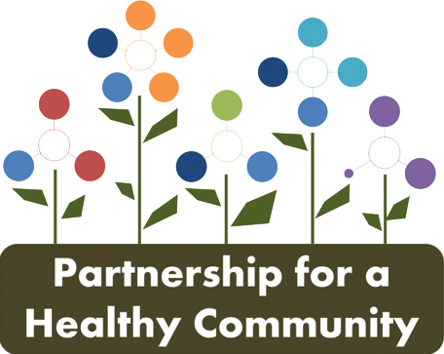
Media Release

Date: July 10, 2018

To: All Media

From: Peoria City/County Health Department
Diana Scott 309-679-6603

Tazewell County Health Department
Sara Sparkman 309-929-0264

Woodford County Health Department
Andrea Ingwersen 309-467-3064, ext 4709

For Immediate Release

Residents to Identify Priority Health Needs in Tri-County

The Partnership for a Healthy Community (Healthy HOI), representing hospitals, clinics, public health, higher education, and social service agencies, is conducting a community health needs assessment in each of the communities it serves. Residents in the tri-county area can participate in an online survey or a paper survey to help identify the most important health issues impacting individuals and families.

“Every community has different health care needs,” said Robert Anderson, President of OSF HealthCare Saint Francis Medical Center. “Through this survey, we hope to get input from a broad set of community members to help us focus our efforts on the challenges and opportunities unique to Peoria and its surrounding areas.”

Dr. Keith Knepp, President, UnityPoint Health - Methodist and Proctor, UnityPoint Clinic - Peoria, and ProHealth Medical Group commented, “Meeting the needs of the community is our top priority and this survey will help identify areas of progress and health needs. We look forward to using the results to benefit our community. “

The survey, as part of the assessment process, is conducted every three years and provides a baseline to address identified health needs. New partnerships have formed and innovative approaches have helped address challenges in some of the current identified priority areas:
- Healthy Eating and Active Living,
- Behavioral Health,
- Cancer - Lung and Breast, and
- Reproductive Health.

Healthy HOI is asking all residents, once again, to take this short survey and help identify the most important health needs in our communities.
The anonymous community survey is available now through August 31. Both English and Spanish versions are available online and at area locations:
Online address www.HealthyHOI.org
Direct link English Tri County - Community Health Needs Assessment
Direct link Spanish Tri County - Encuesta de salud de la comunidad
PAPER COPIES: Peoria, Tazewell, and Woodford County Health Departments

For more information on important community health issues, visit the Partnership website at www.HealthyHOI.org.

The Partnership for a Healthy Community (Healthy HOI) survey committee team:
- Peoria City/County Health Department
- Tazewell County Health Department
- Woodford County Health Department
- Advocate Eureka Hospital
- Heartland Health Services
- Hopedale Medical Center
- OSF HealthCare
- UnityPoint Health
- Bradley University
- Heart of Illinois United Way

###

“Healthy HOI is a community-driven partnership to improve

health and wellness in the Heart of Illinois.”

